PayCart – Mini Wallet + Order Management System
- Have a wallet they can top up
- Can browse a catalog of products
- Can place orders, which:
  - Check inventory
  - Charge the wallet
  - Update order status
All of this happens via 3 backend services:
- API Gateway & Auth Service
- Wallet Service
- Order Service (includes simple inventory + catalog)
Patterns:
- Microservices
- REST APIs
- Events (Kafka)
- Database per service
- Docker
- Basic security
Workaround:
a) Fewer services, richer features
Instead of 8–10 microservices, we use just 3:
- Gateway/Auth
- Wallet
- Order (with built-in inventory + catalog)
But each service is cleanly separated, like a real microservices system.
b) Local infra, free only
- Postgres, Redis, Kafka → all via Docker Compose
- No cloud costs
- GitHub Actions CI/CD
- Run everything on your laptop
c) Simple logic, but real patterns
We don’t do crazy business rules. We simulate a real app with:
- Fake “add money” (no real bank)
- Basic inventory (just quantity in DB)
- Order statuses with a small state machine
- Payment integration via REST call from Order → Wallet
So, you practice real concepts (saga pattern, idempotency, events) without drowning in complexity.
Usage:
Imagine a Postman collection or a simple frontend hitting your APIs.
Main Actors
- User (customer) – has a wallet and places orders
- Admin (optional) – adds products, manages inventory
Typical User Journey
- Sign Up & Login
  - POST /auth/signup
  - POST /auth/login → gets JWT token
- Create Wallet & Add Money
  - POST /wallet → create wallet for user
  - POST /wallet/topup → add money (e.g., ₹1000)
  - GET /wallet/balance → check balance
- Browse Catalog
  - GET /products → list of available items
  - GET /products/{id} → details
- Place Order
  - POST /orders
{
"items": [
{ "productId": 1, "quantity": 2 },
{ "productId": 2, "quantity": 1 }
]
}
  - Flow:
    - Order is created with status CREATED
    - Inventory reserved
    - Wallet charged
    - Order becomes PAID → COMPLETED
- View Orders & Transactions
  - GET /orders → list user’s orders
  - GET /wallet/transactions → full transaction history
Blueprint – Architecture & Design:
High-Level Architecture
Services:
- Gateway & Auth Service
- Wallet Service
- Order Service
Shared Infra:
- PostgreSQL:
  - One DB for Wallet
  - One DB for Orders (and catalog, inventory)
- Redis:
  - Caching, idempotency keys
- Kafka:
  - For events like PAYMENT_COMPLETED, ORDER_CREATED (even minimal usage still looks great)
- Docker Compose:
  - Spins up Postgres, Redis, Kafka, and all services

Text Diagram:
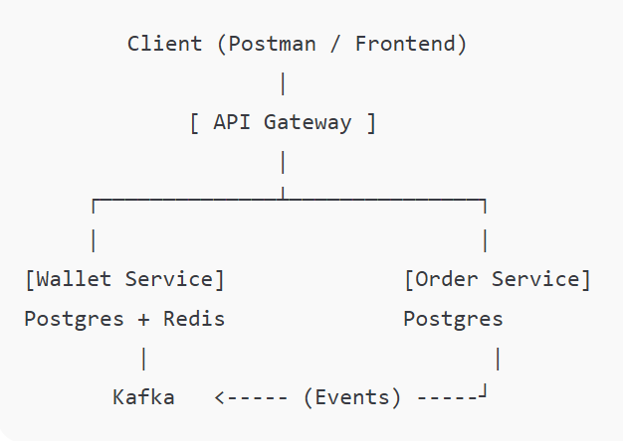
Services & Responsibilities
API Gateway & Auth Service
Responsibilities:
- User registration & login
- JWT generation
- Routes requests:
  - /wallet/** → Wallet Service
  - /orders/**, /products/** → Order Service
- Validates JWT on each request
Main endpoints:
- POST /auth/signup
- POST /auth/login
- GET /me (optional – to test token)
- Proxy routes for wallet & order
Wallet Service
Core responsibilities:
- Manage user wallet
- Add money (credit)
- Make payments (debit)
- Transaction history
- Emit payment events
Entities / Tables:
- wallet
  - id
  - user_id
  - balance
  - status (ACTIVE/BLOCKED)
  - created_at, updated_at
- wallet_transaction
  - id
  - wallet_id
  - type (CREDIT/DEBIT)
  - amount
  - status (SUCCESS/FAILED/PENDING)
  - description
  - correlation_id (for idempotency)
  - created_at
Important design bits:
- Idempotency with correlation_id:
  - When Order Service asks “Charge ₹500 for order #123”, it sends a correlationId = "ORDER_123".
  - Wallet Service checks if it already processed this correlation ID.
- Emits Kafka event:
  - PAYMENT_COMPLETED or PAYMENT_FAILED
Example endpoints:
- POST /wallet – create wallet for current user
- POST /wallet/topup – credit money
- POST /wallet/pay – debit money for a specific order
- GET /wallet/balance
- GET /wallet/transactions
Order Service (includes Catalog + Inventory)
Core responsibilities:
- Manage products (simple CRUD or even just seed data)
- Manage inventory (quantity per product)
- Handle orders
- Orchestrate payment with Wallet Service
- React to payment status (via Kafka or direct response)
Entities / Tables:
- product
  - id
  - name
  - description
  - price
  - currency
  - status (ACTIVE/INACTIVE)
- inventory
  - id
  - product_id
  - available_quantity
- orders
  - id
  - user_id
  - total_amount
  - status (CREATED / PENDING_PAYMENT / PAID / COMPLETED / CANCELLED)
  - created_at
- order_item
  - id
  - order_id
  - product_id
  - quantity
  - price_at_purchase
Main flows:
🔹 Place Order Flow:
- User → POST /orders
- Order Service:
  - Calculates total price
  - Checks inventory for each product
  - Creates order with CREATED
  - Option A (simpler): synchronous call to Wallet /pay
  - If payment success:
    - Deduct inventory
    - Set order PAID → COMPLETED
  - If payment fails:
    - Set order CANCELLED
🔹 Payment Event Flow (if you use Kafka):
- Order Service creates order as PENDING_PAYMENT
- Calls Wallet Service to start payment
- Wallet emits PAYMENT_COMPLETED event
- Order Service consumer listens, updates order status
Example endpoints:
- GET /products
- GET /products/{id}
- POST /orders
- GET /orders
- GET /orders/{id}
Tech Stack
- Language: Java 17
- Framework: Spring Boot 3, Spring Web (or WebFlux for gateway)
- DB: PostgreSQL (Wallet DB + Order DB)
- Cache: Redis
- Messaging: Kafka
- Security: Spring Security + JWT
- Infrastructure: Docker, Docker Compose
- Testing: JUnit 5, Testcontainers (for Postgres/Kafka)
Implementation Phases (High-Level)
You can map each of these to Todoist sections:
- Phase 1 – Skeleton & Infra
  - Set up repo, Docker Compose, basic Spring Boot apps
- Phase 2 – Auth & Gateway
  - JWT auth, routing
- Phase 3 – Wallet Service
  - Core wallet, topup, pay, transactions
- Phase 4 – Order Service
  - Catalog, inventory, place order, integrate payment
- Phase 5 – Events + Polishing
  - Kafka events (optional but nice)
  - Better error handling and logs
  - README and Postman collection

